**TEST AUTOMATION SELENIUM GRID SETUP AND PARALLEL TESTS EXECUTION:**

**23/04/2015**

**Authors:**

**Venkat Kintali**

**Reviewer**

**Pratik Gilda**

**Table of Content**

1 selenium GRID SETUP 1

**2 PARALLEL TESTS EXECUTION …………………………………………………………………………………………8**

1 SELENIUM GRID SETUP AND PARALLEL TESTS EXECUTON

Selenium-Grid allows you run your tests on different machines against different browsers in parallel. That is, running multiple tests at the same time against different machines running different browsers.

**Step 1:**

For Selenium Grid Setup we have to setup CLASSPATH and PATH properties.

In Advanced system settings/ Environment Variables setup java path:

Create a new system variable (if it is not created):

Name: JAVA_HOME

Value(the location of the jdk): C:\RAD\java\jdk7

In to the Path variable add:

The location of jre: C:\RAD\java\jdk7\bin;

For PATH properties setup we can use below path:

Go to my computer->Properties->Advanced System Settings ->Advanced->Environment Variables ->User Variable ->New

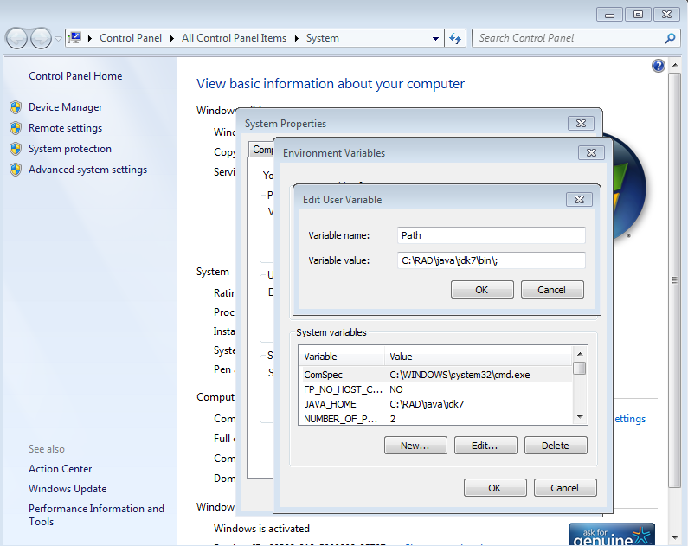

For CLASSPATH properties setup we can use below path :

Go to my computer->Properties->Advanced System Settings ->Advanced->Environment Variables ->System Variable ->New

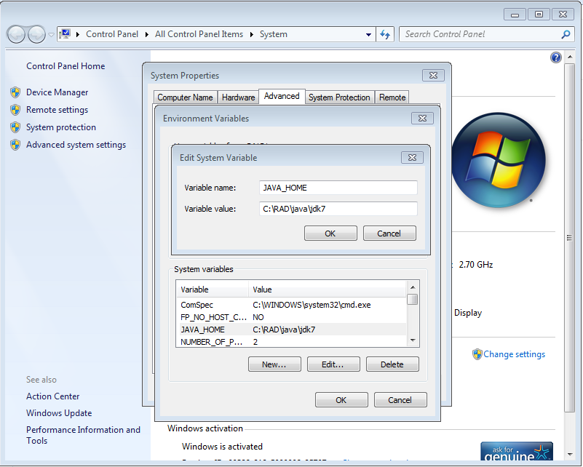

**Step 2**: You can test whether your path and class path properties were correct or not in the commend prompt

Open the CMD prompt and go to your bin folder .

i.e : C :> cd C:\RAD\java\jdk7\bin ->Enter

C:\RAD\java\jdk7\bin>Javac (Compile Time Environment)

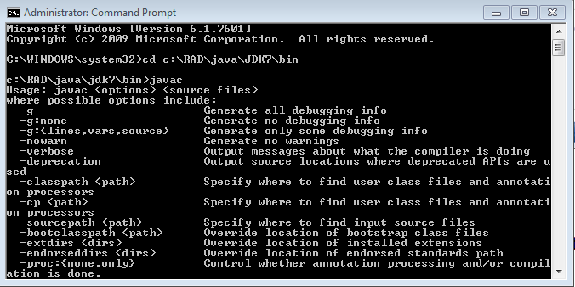

C:\RAD\java\jdk7\bin>Java (Run Time Environment)

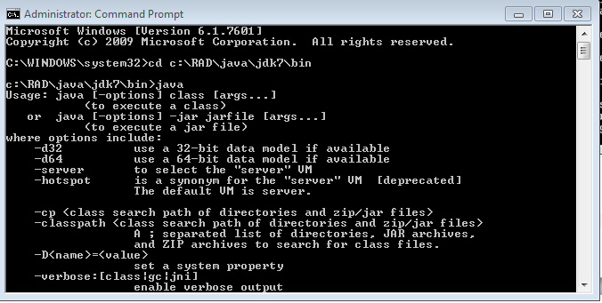

**Step 3**:

Download selenium-server-standalone-2.41.0.jar file and kept into under RAD folder

i.e C:\RAD\dev\V3_TRUNK\TestAutomation\SeleniumGrid\selenium-server-standalone-2.41.0.jar

**Step 4**: Install selenium and testing to Eclipse (Start Selenium Server):

Open new command prompt (with administrator privileges) and type below command. Run the following command to make your machine as hub

C:\RAD\java\jdk7\bin>java -jar C:\RAD\dev\V3_TRUNK\TestAutomation\SeleniumGrid\selenium-server-standalone-2.41.0.jar -role hub

(After execution of above commend our selenium server will start)

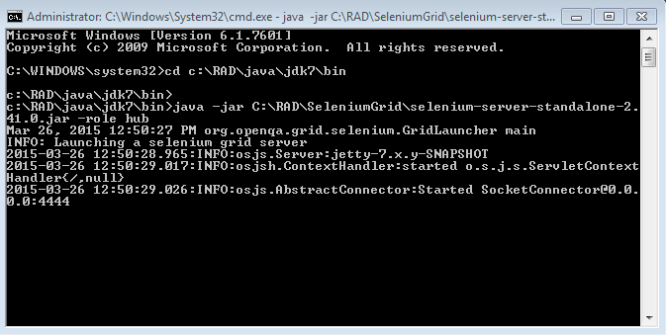

**Step 5**: Start Selenium Node

Open a new command prompt window, go to C:\RAD\java\jdk7\bin and enter the following command to register the browser to the Selenium Grid:

Run the following command to make your machine as a node

1. **To run nodes locally :**

In this case you can use “localhost “ while constructing URL.

C:\RAD\java\jdk7\bin>java -jar C:\RAD\dev\V3_TRUNK\TestAutomation\SeleniumGrid \selenium-server-standalone-2.41.0.jar -role node -hub <http://localhost:4444/wd/hub>

If you want to check all nodes in the console you can use below command

<http://localhost:4444/grid/console>

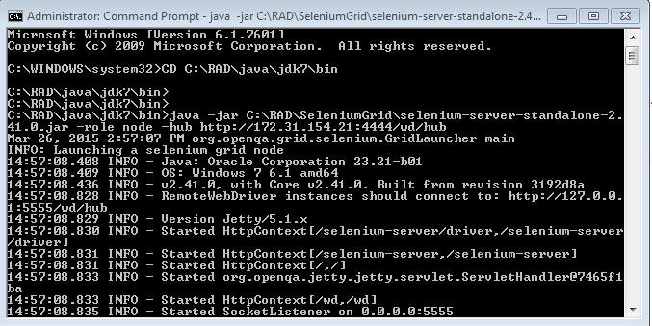

1. **To run nodes remotely :**

In this case you can use other machine IP address while constructing URL.

C:\RAD\java\jdk7\bin>java -jar C:\RAD\dev\V3_TRUNK\TestAutomation\SeleniumGrid selenium-server-standalone-2.41.0.jar -role node -hub <http://172.31.228.26:4444/wd/hub>

If you want to check all nodes in the console you can use below command

<http://172.31.228.26:4444/grid/console>

**Note :** e.g. 172.31.228.26 is server(hub) machine IP Address where we can start selenium server .

While running the nodes we could use this server machine IP address in the part of url constructing.

**Other way to Start Selenium Node :**

c:\RAD\java\jdk7\bin>java -jar C:\RAD\dev\V3_TRUNK\TestAutomation\SeleniumGrid \selenium-server-standalone-2.41.0.jar -role node -hub http://localhost:4444/wd/hub -browser browserName=firefox,maxInstances=2

Above commend maxInstance will determine the max number of the browsers. If it is set to 2 than maximum 2 browsers(tests) are able to run parallel.

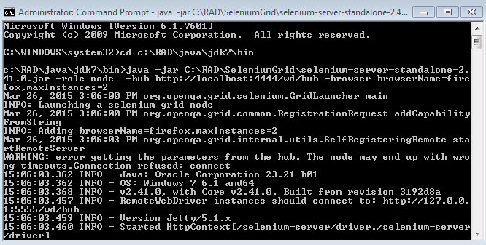

**Parallel Tests Execution**:

**Step 1** :

In Testng.xml we have to add two properties programmatically .Those are

1) parallel and 2) thread-count

There is the “parallel” parameter. Set to “tests” because we want to run tests parallely. The other parameter is the “thread-count”. If it is set to 2, than two browsers will be opened.

Code in Testng.xml :

<!DOCTYPE suite SYSTEM "<http://testng.org/testng-1.0.dtd>">

<suite name="Parallel test runs" parallel="tests" thread-count="2">

**Step 2** :

You can give two packs names in “config.properties “based on Step1 setting your framework will open two browsers simultaneously .one browser per one pack and another browser per second pack .

For Example In config.properties :

testlab=SampleScripts;TUI

Here you have given two packs That are SampleScript and TUI . So our frame work will open one browser per SampleScript pack and another browser per TUI pack

**Step 3** :

How to run Parallel Execution ?

Go to build.xml ->Run as ->Ant Build